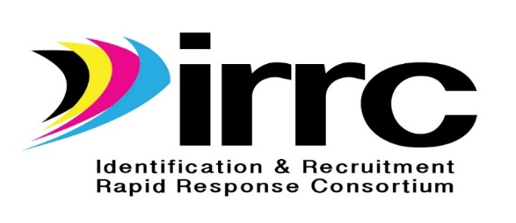
Equity Materials Review Rubric Process

IRRC has developed a rubric to review all materials using an equity process to ensure that all materials contain language and procedures that are inclusive of considerations of race, gender, national origin, age, religion, and disability, and has put out guidelines to ensure equal access in accordance with tenets of Federal guidance for Section 427 of GEPA. This rubric is intended to be an adaptable tool for reviewing the various components of materials and products created by IRRC.
Expected benefits are:
- To eliminate barriers that restrict access to materials;
- To ensure materials reflect the diversity of the student population; and
- To provide all users with access to materials.
Material

Title of Material
Prepared/designed by
Target Population
Subject Matter
Name of Reviewer
State
Date Reviewed

Equity Rubric

Component | Criteria | 3 | 2 | 1 | 0
 |  | Exceeds | Meets | Does not meet | Not evident
Design | Design and format is legible. Colors are easy to distinguish. Fonts used are larger than 10 point.
Content | Content avoids being offensive to any group based on race, gender, sexual orientation, age, religion, ethnicity, socioeconomic status, national or regional origin, or disability.
Layout | Layout is organized, clear, consistent, and logical. Layout avoids a format that may be considered exclusionary to some groups based on equity criteria.
Language | Language is appropriate for the intended audience. Language is avoided that can be deemed as offensive or inappropriate. When possible, material may be available upon request in other formats such as large print, Braille, or audiotape.
Visuals | If visuals are included, they depict the diversity of the broader state/country/world. People are shown interacting in racially/ethnically integrated groups or situations. People are pictured against backgrounds and in activities that are consistent with their realistic and varied cultures.
Comments or suggestions:

Resources:

REL Northwest at http://educationnorthwest.org/
Teaching for Change: Building Social Justice Starting in the Classroom at http://www.teachingforchange.org/
U.S. Department of Health and Human Services, Office for Civil Rights at http://www2.ed.gov/about/offices/list/ocr/index.html

